**The Title of the Poster Should be Clear, Concise, and Connected with the Research Objective, and Outcomes Paper Title**

**Author Name1, Author Name2, Author Name3\***

1. Department, Institute/University, City, Country, Email; 2. Department, Institute/University, City, Country, Email; 3. Department, Institute/University, City, Country, Email

* Corresponding/Presenting Author

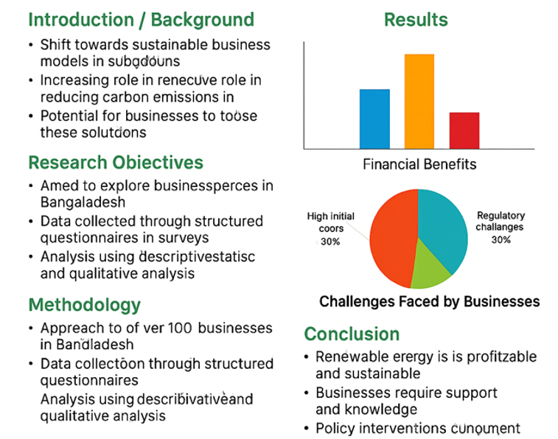

**References Acknowledgement** (If any)

* APA 7th Edition Style